INFS 778 Deep Learning Quiz 2: Backpropagation/Keras (total 25 points)
Due: 6/16 Sunday by Midnight 11:59 PM
- Consider a 2-dimensional neuron (with inputs x and weights w) that uses the sigmoid activation function. (11 points)
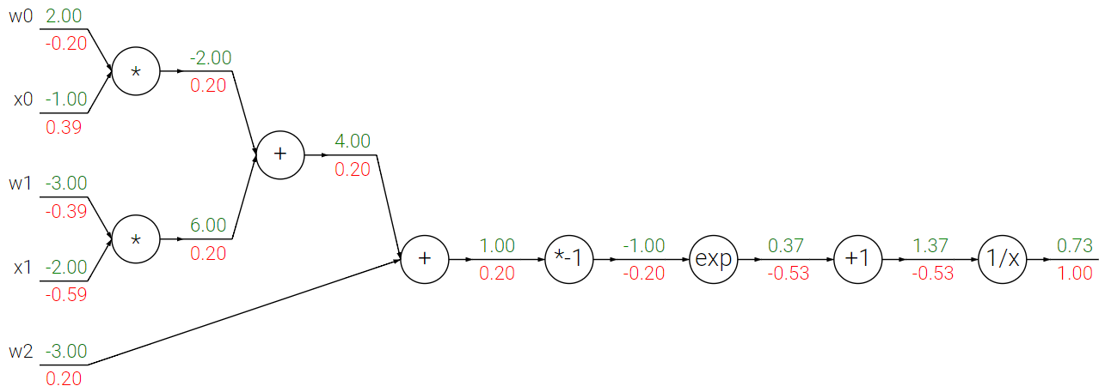
Now, perform the forward pass computation with x0 = 2, x1 = 0, and the weights are the same.
Please use proper symbols such as to show your answers clearly.

And then perform the backward pass computation with backpropagation/chain rule.
Hint: The transformation and the simple first-order derivatives are given as: ,

- TensorFlow/Keras Multiple Choice Questions. (14 points)
1). Which layer in Keras is a widely used layer for creating a fully connected layer in the neural network?
- Flatten layer
- Dropout layer
- Dense layer
- Permute layer
2). Which of the following methods is used to add layers in a sequential model?
- Layers_add()
- Add_layers()
- Add()
- Layers()
3). Which Keras layer would you use if you want to reduce overfitting in neural network models?
A. Pooling layer
B. Dropout layer
C. Permute layer
D. Dense layer
4). To train your model in Keras, which of the following methods would you use?
A. Predict()
B. Model()
C. Fit()
5). To predict your model, which of the following methods would you use?
- Predict()
- Model()
- Fit()
6). Which functions in Keras help you to find faults or deviations in the learning process?
- Keras optimizer function
- Keras metrics
- Keras loss function
7). Which of the following permits you to evaluate the performance of your model?
- Keras optimizer function
- Keras metrics
- Keras loss function

1.Answer:

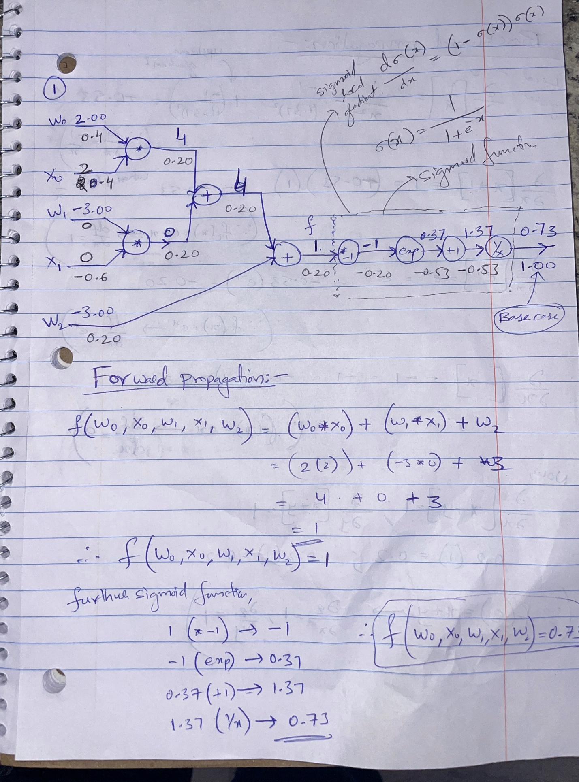
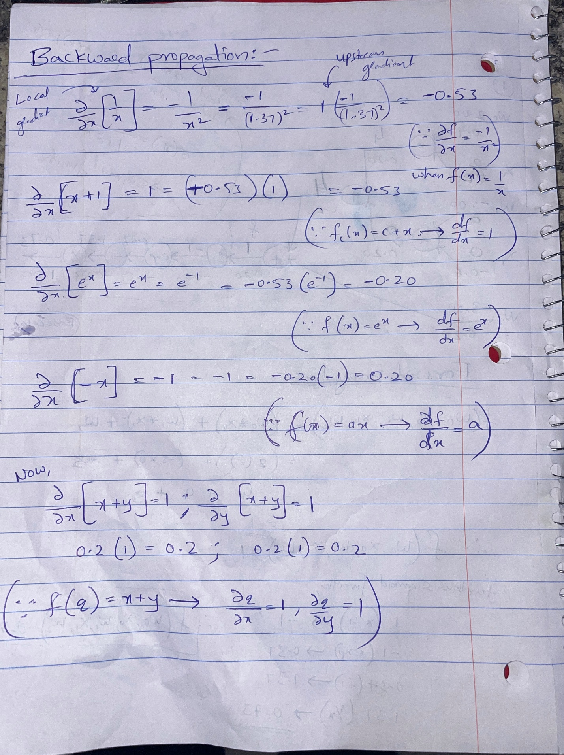
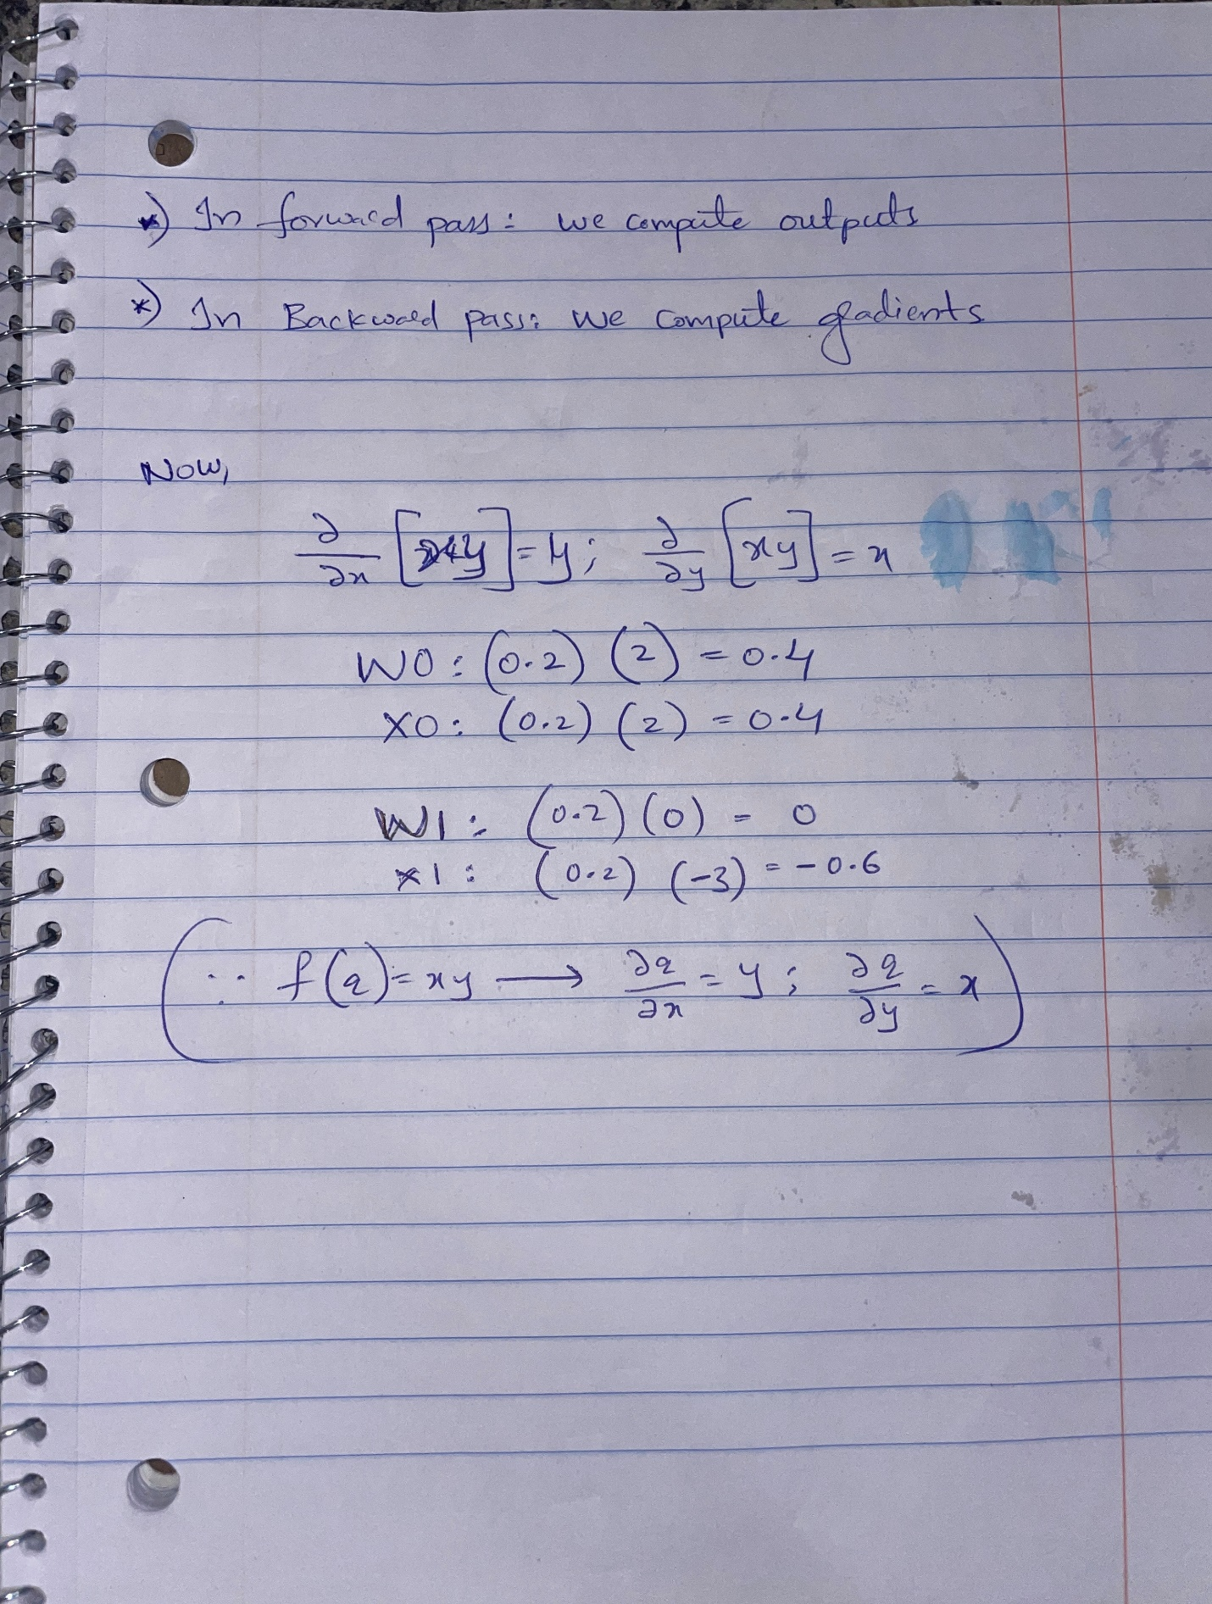

Python Code

Sigmoid Function
In [ ]:
import math

def sigmoid(x):
return 1 / (1 + math.exp(-x))

Forward Propagation
In [27]:
def forwardp(w0, x0, w1, x1, w2):
a = w0 * x0
b = w1 * x1
c = a + b
d = c + w2
sig = sigmoid(d)
return sig

result = forwardp(2, 2, -3, 0, -3)
print(result)
0.7310585786300049

Backward Propagation
In [29]:
def backp(w0, x0, w1, x1, w2):
a = w0 * x0
b = w1 * x1
c = a + b
d = c + w2
sig = sigmoid(d)

grad_sig = 1.0
grad_d = grad_sig * (1 - sig) * sig
grad_w2 = grad_d
grad_c = grad_d
grad_a = grad_d
grad_b = grad_d
grad_w1 = grad_b * x1
grad_x1 = grad_b * w1
grad_w0 = grad_a * x0
grad_x0 = grad_a * w0

return grad_d, grad_w2, grad_c, grad_a, grad_b, grad_w1, grad_x1, grad_w0, grad_x0

w0 = 2
x0 = 2
w1 = -3
x1 = 0
w2 = -3

grad_d, grad_w2, grad_c, grad_a, grad_b, grad_w1, grad_x1, grad_w0, grad_x0 = backp(w0, x0, w1, x1, w2)

print(grad_d, grad_w2, grad_c, grad_a, grad_b, grad_w1, grad_x1, grad_w0, grad_x0)
0.19661193324148185 0.19661193324148185 0.19661193324148185 0.19661193324148185 0.19661193324148185 0.0 -0.5898357997244456 0.3932238664829637 0.3932238664829637

